1. Create a Registration Form using HTML 5 and CSS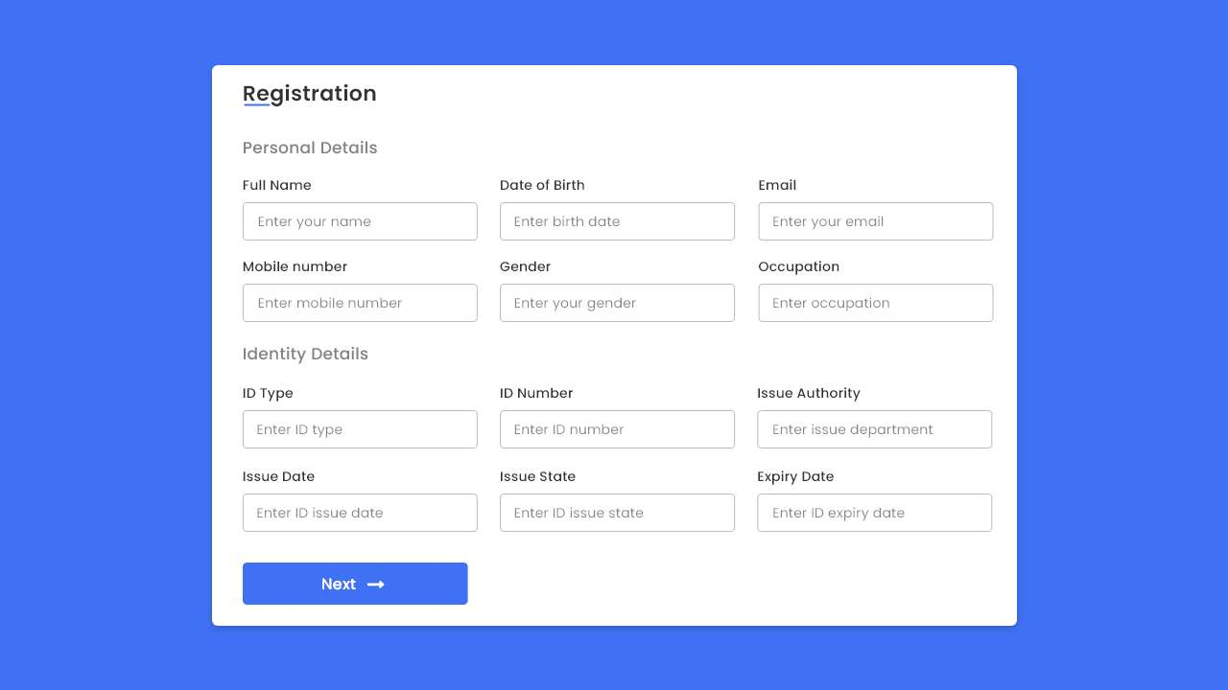

Add validations, use event handlers like onHover, onClick

When you submit the form and click on the next button it should display the data in the console

And should take you to the next page



Which will be thank you page

1. Write an Array list of Competitive exam courses like JEE, CAT, NEET and this Array list will have properties course_id, course_name, course_teacher, course_duration, total_fees. Add 15 elements to the list and the write Lambda expression to sort this list based on price in both ascending and descending order as well as duration form shortest to longest.

—-------------------------------------------------------------------------------